
Eaglesoft Quickbooks Deposit
James Russo
Email: jr@halo3.net

This application provides the ability to import payments recorded into Eaglesoft directly into QuickBooks with just a few button clicks. This document describes the configuration and usage of the application.

Installation
To install the application, simply run the installer on the same machine where QuickBooks is installed. Once the application is installed, you can run it via the Start Menu. The Group is called ‘Eaglesoft Deposit’.

Running
To run the application you will need to start it from the Start Menu. In order for the application to run, you must have both Quickbooks and the Eaglesoft database server running. The actual Eaglesoft application does not need to be running. If either of these are not running, it will warn you when the application attempts to start.

The first time it is run, QuickBooks will prompt you to allow access to the QuickBooks Application. You must accept this warning in order for the application to work. Figure 1 show the QuickBooks dialog box. You should select the ‘Yes, whenever this QuickBooks company file is open.’ There will also be some warnings about a lack of certificate, which you can safely ignore for now. I plan on obtaining a certificate for the application, but have not yet done so.

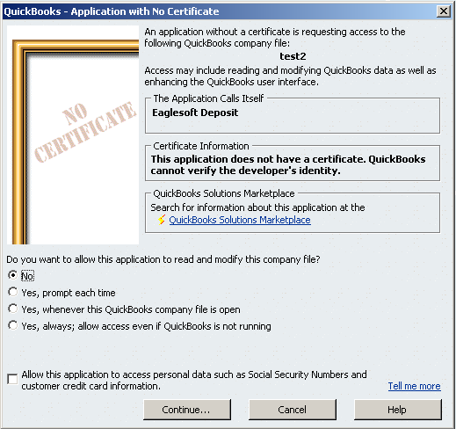
Figure 1 – QuickBooks Warning

Also, the first time the application is run you will need to configure the mappings between the Eaglesoft Payment types and the QuickBooks payment types. Once those are configured you will need to setup the Deposits where those pay types belong. This is all explained the in the following section.

Configuration
In order to use the application, it must first be configured so it knows how to map the payments made in Eaglesoft into QuickBooks deposits. There are two steps to this configuration. The first is to define the payment type mappings. The purpose of the payment type mappings is to associate the payment types defined in Eaglesoft with payment information in QuickBooks. A payment type in Eaglesoft maps to a payment type, income account, and received from value in QuickBooks. These are the same values which are included when manually putting in a deposit into QuickBooks. The second step is to setup the actual deposits which will be made when exporting a days worth of payments into QuickBooks. In this step you create a deposit, give it a memo and bank account and then associate with it any number of payment types. You can also optionally limit the number of times each payment type appears in a specific deposit before creating a new deposit for the remaining items.

When the system first starts up it will recognize that there are no payment types defined and will bring you to the payment type mappings dialog. Once the payment types are configured you will then need to configure the deposits.

Payment type mappings
The payment type mappings associate the Eaglesoft payment types to three pieces of QuickBooks information. This mapping is configured via the Payment type Mappings dialog available from the Setup menu in the application. A picture of the payment type mapping dialog is shown below in Figure 2.

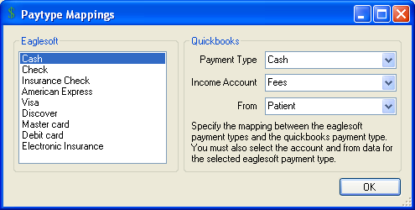
Figure 2 – Payment type mapping Dialog

In this dialog you will see all the Eaglesoft pay types show in the list on the left. You will need to go through each of them and specify the information on the from the pull downs on the right. Each Eaglesoft payment type will have the following information associated with it:
- QuickBooks payment type – The payment type used in QuickBooks for this Eaglesoft payment type. (Ex: Insurance Check in Eaglesoft maps to Check in QuickBooks.)

- Income Account – The QuickBooks income account where payments of this type will go. Typically it will be something like Fees or Procedures.

- From – The QuickBooks ‘Customer’ who this payment will be from. Typically it will be ‘Patient’ or perhaps ‘Insurance Company’ for insurance checks.

Once all the payment types are correctly mapped, you can move on to setting up the deposits which will include those payment types.

Deposit Setup
The application is very flexible in that it can setup multiple deposits each containing one or more payment types. Here is a quick example of how this is used.

In your practice you collect cash, check, Visa, Mastercard, Debit Card, American Express and Discover. The credit card company makes up to 3 daily deposits into your bank account. The first deposit is for all Visa, Mastercard and Debit transactions, the second is for all American Express transactions and the final one is for all Discover card transactions. You would also have a deposit which included all the Cash and Check payments made for a certain day. In this situation you would have configured the following deposits:
- Cash/Check Deposit including the Cash and Check Payment Types.
- Visa/Mastercard/Debit Card Deposit including the Visa, Mastercard and Debit card payment types
- American Express Deposit including the American Express payment type.
- Discover Card Deposit including the Discover card payment type.

The deposits are configured via the Deposit Configuration dialog available via the Setup menu of the main application. An example of this dialog is shown in Figure 3.

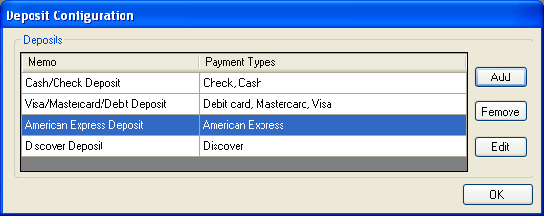
Figure 3 - Deposit Configuration Dialog

Adding a new Deposit
To add a new deposit, click the add button and you will be presented with the Add Deposit dialog which is shown in Figure 4. This dialog contains three main fields. The first field is the Memo field which will be included on the deposit. Next, you would configure the ‘Deposit to Account’ field which is the bank account in QuickBooks where this deposit will be made. Finally, you would configure which payments would be included in this specific Deposit and optionally the maximum number of times the specific payment type will be included.

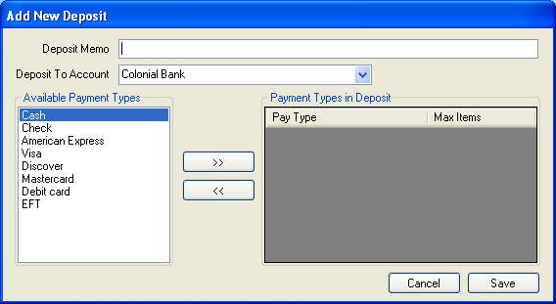
Figure 4 - Add Deposit Dialog

To add a payment type to the deposit, you would first select the type from the list of available payment types on the left side of the form. Once selected, you would click the right arrow (‘>>’) causing the payment type to be added to this deposit. This is shown in Error: Reference source not found. Once a payment type is associated with a specific deposit, you can optionally limit how many times that payment time will be included before another deposit of the same type will be made. To set a maximum simply select the maximum value from the pull down list on the right hand side of the dialog. The limit on specific payment types is needed in certain situations. One situation where this is commonly used is when there is a limit to the maximum number of checks which can be included on a deposit split. By setting that maximum value for the Check payment type you can automatically break up your Cash/Check deposit into multiple deposits allowing the deposit slips to be printed. The other situation may be that when using the direct deposit feature used by certain insurance companies individual deposits are made for each EOB. You could then set the limit to 1 for those payment types and have them be correctly represented as a single deposit in QuickBooks. Having all this information correctly represented in QuickBooks greatly speeds monthly reconciliation.

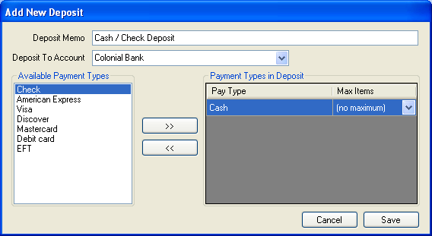
Figure 5 - Adding Payment Types to Deposit

Editing a Deposit
To edit an existing deposit, simply double click on the deposit in the list of highlight the deposit and click the Edit button. The same Deposit Configuration dialog screen will appear allowing you to edit the deposit information and associated payment types.

Deleting a Deposit
To delete an existing deposit simply highlight the deposit and click the Delete button. Once the deposit is deleted, the payment types associated with the deposit will become available to be added to other deposits.

Application Usage
The application is very simple to use once configured. It will make your daily deposits much easier with absolutely no redundant data entry. Once all the payment types and deposits are configured, you are ready to use the application. When starting up the application, you will see a splash screen while the application loads and obtains a connection to Eaglesoft and QuickBooks. QuickBooks must be running in order for the application to start. The application will notify you if it cannot communicate with either Eaglesoft or QuickBooks.

Once the application is running and visible on the screen, you will see the main screen as shown in Figure 6.

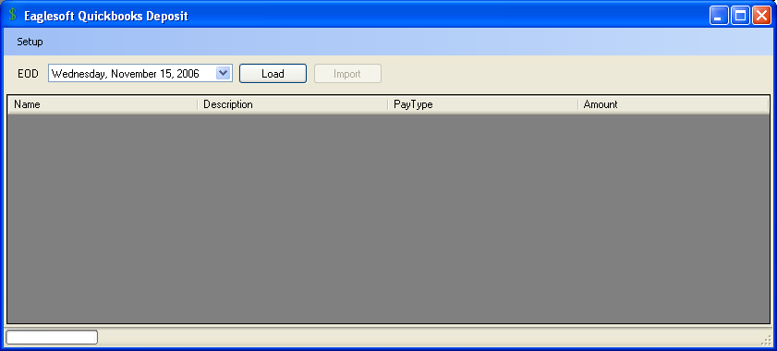
Figure 6 - Main Screen

To perform a deposit, you would first need to select the End-Of-Day date from the date pull down in the top-left of the application. Once the correct date is selected, you would click the Load button to load all the payments from Eaglesoft for the specified date. Once loaded, the individual payments will be shown in the table area of the application. Listed there will be the payee’s name, a description of the payment, the payment type (in Eaglesoft), and finally the amount of the payment. An example of this screen is shown in Figure 7
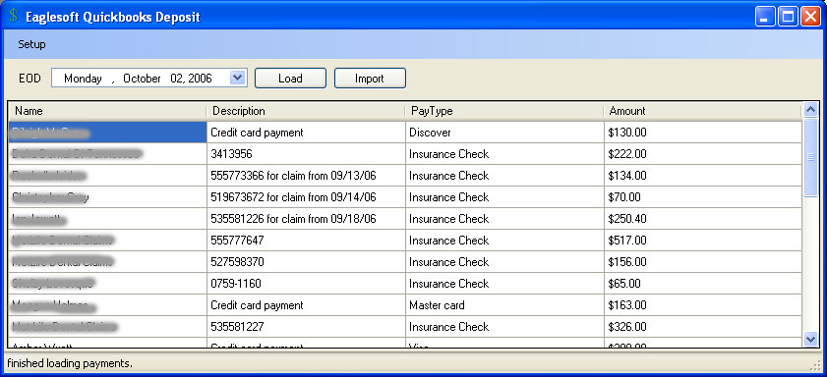
Figure 7 - Populated Main Screen

You should then review the results, and if acceptable click on the Import button to import those transactions into QuickBooks. That’s it your done. You can then go into QuickBooks print your deposit slip and head to the bank.

